# BUBBLE

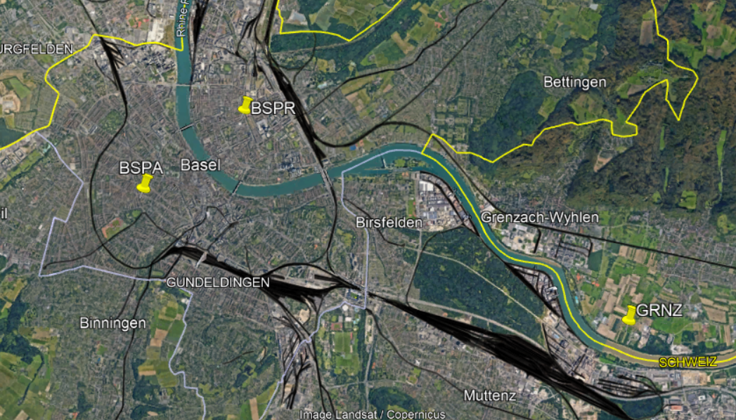

Figure 1 Map of weather station network during BUBBLE campaign in Basel, Switzerland, from June 2002 to July 2002.

## Campaign introduction

The BUBBLE campaign has been conducted in Basel, Switzerland from June 10th to July 9th, 2002[1]. As summarized in [2], [3], the blocks building types in BSPR (Ue1) are mainly 3 to 4 stories residential buildings, while in BSPA (Ue2) are 3 to 5 stories mixed residential/commercial buildings.

The forcing weather observations dataset is composed of GRNZ (R1) rural filed measurements, which has been formatted as EnergyPlus weather file (EPW) to the force the Coupled-EP-VCWG. The validating weather observations are compared to the model predictions of air temperature within building heights on a 10mins basis.

|  |  |  |  |
| --- | --- | --- | --- |
|  |  | **Ue1** | **Ue2** |
| **UWG** | **Theta of Canyon [degree relative to north, -90 to 90]** | 65 | -20 |
| **Mean building heights[m]** | 14.6 | 12.5 |
| **Urban domain height [m]** | 50 | 40 |
| **Albedo (roof, wall, veg)** | 0.15,0.15,0.2 | 0.11,0.11,0.2 [4] |
| **Emissitivities**  **(roof, wall)** | 0.95 | 0.95 |
| **Others** | Fveg_G = 0;  Fbare_G = 0;  Fimp_G = 1 | Fveg_G = 0.31;  Fbare_G = 0;  Fimp_G = 0.69 |
| **IDF** | **Prototype IDF models** | Post80s  MidRiseApart 4C | Post80s  MidRiseApart 4C |
| **Internal Gains** | Residential | Residential |
| **Cooling System** | No cooling | No cooling |
| **Heating System** | Furnace | Furnace |
| **Wall** | Concrete 20mm  Insulation 30mm | Concrete 20mm  Insulation 30mm |
| **Roof** | Tile 60mm  Concrete 200mm  Insulation 30mm | Tile 60mm  Concrete 200mm  Insulation 30mm |
| **Floor** | Concrete 200mm | Concrete 200mm |
| **Forcing Weather Observations** | | R1  (1.2 m air temperature) | R1  (1.2 m air temperature) |
| **Validating Weather Observations** | | Air temperature profiles [2.6, 13.9, 17.5, 21.5, 25.5, 31.2] m | Air temperature profiles [3, 15.8, 22.9, 27.8, 32.9] m |

## Performance

Ue1

|  |  |  |  |
| --- | --- | --- | --- |
| CVRMSE (%) | Rural | OnlyVCWG | Bypass |
| 2.6m Direct | 10.56 | 10.32 | 10.8 |
| 2.6m Real P0 |  | 9.71 | 10.15 |
| 2.6m Real EPW |  | 10.02 | 10.57 |
| 13.9m Direct | 10.56 | 11.43 | 9.42 |
| 13.9m Real P0 |  | 12.22 | 10.54 |
| 13.9m Real EPW |  | 11.06 | 9.1 |

Ue2

|  |  |  |  |
| --- | --- | --- | --- |
| CVRMSE (%) | Rural | OnlyVCWG | Bypass |
| 3m Direct | 8.14 | 12.2 | 14.26 |
| 3m Real P0 |  | 9.16 | 10.66 |
| 3m Real EPW |  | 11.57 | 13.68 |
| 15.8m Direct | 8.14 | 11.05 | 10.48 |
| 15.8m Real P0 |  | 11.62 | 10.56 |
| 15.8m Real EPW |  | 10.49 | 9.85 |

# CAPITOUL

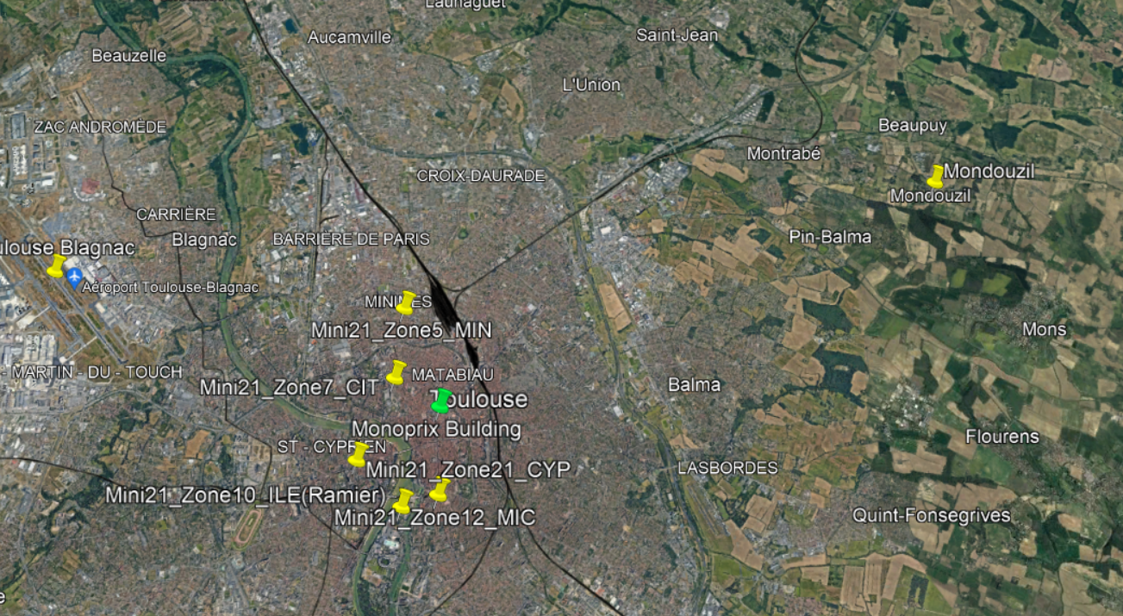

Figure 2 Map of weather station network during CAPITOUL campaign in Toulouse, France, from Jan 2004 to Feb 2005.

## Campaign introduction

The CAPITOUL campaign has been conducted in Toulouse, France from Jan 2004 to Feb 2005[5]. As summarized in [3], the blocks building types at the central location of the city, next to Monoprix building (MNP) is selected as the representative of urban conditions. In this study, Post 80s Medium Office 4B from DOE website [6] has been used as the prototype building energy model, while [3] defined the MNP internal heat gains type as residential.

As for the forcing weather observations dataset, it is formatted as hourly EPW file from minutely measurements of the reference weather station located at Mondouzil (MON). It should be noted that there were some missing data during the 14 months experiments. And the missing data has been filled will interpolated data from their neighboring measurements before they were formatted as hourly EPW file. Specifically, the dry bulb air temperature, atmospheric pressure, relative humidity, and dew point have been calculated from rural field measurements to create the hourly EPW file. The validating weather observations are compared to the model predictions of air temperature within building heights on a 5mins basis. As illustrated from the below figure, the air temperature sensor is installed at the top of the Pomme street, with a height of 19m above the ground level [3], [5].

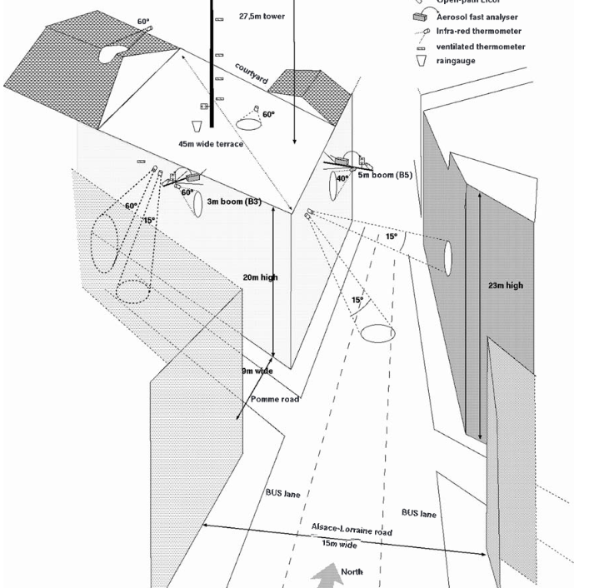

Figure 3 Schematic view of the MNP site from CAPITOUL campaign [5]

|  |  |  |
| --- | --- | --- |
|  |  | **MNP** |
| **UWG** | **Theta of Canyon** | -56 |
| **[degree relative to north, -90 to 90]** |
| **Mean building heights[m]** | 20 |
| **Urban domain height [m]** | 60 |
| **Albedo (roof, wall, veg)** | 0.25, 0.25, 0.25 |
| **Emissitivities** | 0.95 |
| **(roof, wall)** |
| **Others** | Fveg_G = 0.2; |
| Fbare_G = 0; |
| Fimp_G = 0.8  Width canyon = 9m [5]  Width roof = 20m (Google Earth) |
| **IDF** | **Prototype IDF models** | Post80s |
| MediumOffice 4B |
| **Internal Gains** | Commercial |
| **Cooling System** | No cooling |
| **Heating System** | Furnace |
| **Wall** | Brick 300mm Insulation 30mm |
| **Roof** | Tile 60mm Wood 200mm Insulation 30mm |
| **Floor** | Concrete 20mm |
| **Forcing Weather Observations** | | MON |
| (2 m air temperature atmospheric pressure, relative humidity, dew point) |
| **Validating Weather Observations** | | 19 m air temperature |

## Performance

|  |  |  |  |
| --- | --- | --- | --- |
| CVRMSE (%) | Rural | Only-VCWG | Bypass |
| 19m Direct | 7.27 | 18.07 | 15.88 |
| 19m Real P0 |  | 18.56 | 16.41 |
| 19m Real EPW |  | 19.69 | 17.74 |

# Vancouver Rural Model

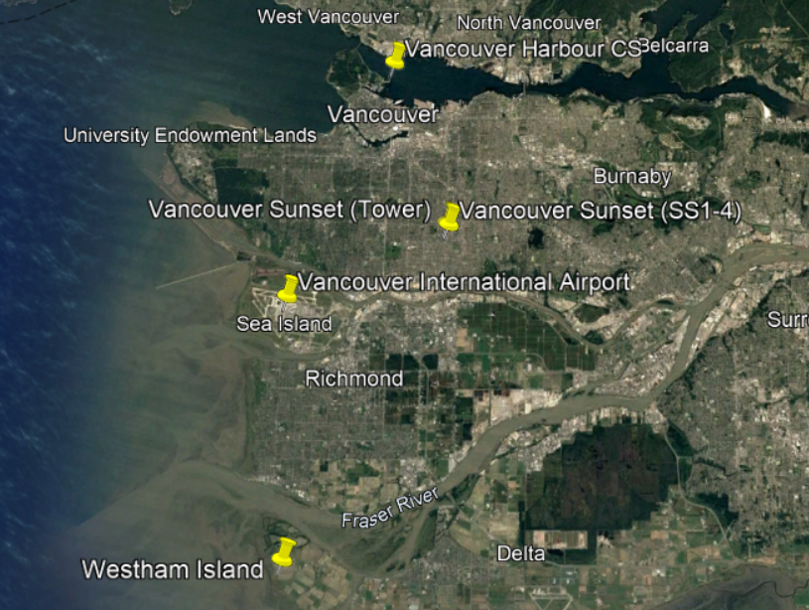

Figure 4 Map of weather station network during Vancouver Sunset campaign in Vancouver, Canada, from May 2008 to Sep 2008.

## Campaign introduction

The Sunset neighborhood field measurements campaign has been conducted in Vancouver, Canada, in 2008. As summarized in [7], the neighborhood is classified as LCZ-9 “open-set lowrise” and primarily residential area. In this study, Post 80s Small Office 4C from DOE website [6] has been used as the prototype building energy model, while its internal gains has been modified as residential type.

As for the forcing weather observations dataset, CAN_BC_Vancouver.718920_CWEC has been selected as the EPW template[8]. And the Integrated Surface Dataset (Global, Hourly) [9]data for weather station 718920 (Vancouver International Airport for 2008) has been used as the actual rural measurements. And the missing data has been filled will interpolated data from their neighboring measurements before they were formatted as hourly EPW file. TMP, DEW, SLP from the Integrated Surface Dataset have been used to calculate real time dry bulb air temperature, dew point temperature, relative humidity, and atmospheric pressure. The validating weather observations are compared to the model predictions of air temperature within building heights on a 30mins basis.

|  |  |  |
| --- | --- | --- |
|  |  | **Sunset Neighborhood** |
| **UWG** | **Theta of Canyon** | 0 |
| **[degree relative to north, -90 to 90]** |
| **Mean building heights[m]** | 6.5 |
| **Urban domain height [m]** | 20 |
| **Albedo (roof, wall, veg)** | 0.13, 0.2, 0.27 |
| **Emissitivities** | 0.95,0.95 |
| **(roof, wall)** |
| **Others** | Fveg_G = 0.5; |
| Fbare_G = 0; |
| Fimp_G = 0.5 Width canyon = 23m[2]; Width roof = 10m[2] |
| **IDF** | **Prototype IDF models** | Post80s |
| SmallOffice 4C |
| **Internal Gains** | Residential |
| **Cooling System** | Cooling |
| **Heating System** | Furnace |
| **Wall** | - |
| **Roof** | - |
| **Floor** | - |
| **Forcing Weather Observations** | | Int'l Airport |
| (4.26 m air temperature atmospheric pressure, relative humidity, dew point) |
| **Validating Weather Observations** | | Air temperature profile [1.2, 26]m |

## Performance

|  |  |  |  |
| --- | --- | --- | --- |
| CVRMSE (%) | Rural | OnlyVCWG | Bypass |
| 1.2m Direct | 8.83 | 16.6 | 17.88 |
| 1.2m Real P0 |  | 21.19 | 23.33 |
| 1.2m Real EPW |  | 16.77 | 17.87 |
| 26m Direct | 8.83 | 17.56 | 17.56 |
| 26m Real P0 |  | 19.14 | 19.14 |
| 26m Real EPW |  | 17.91 | 17.91 |

# Vancouver Top Forcing

## Campaign introduction

The overall settings for this campaign is pretty much the same as Vancouver Rural Model, except for the followings: Using an external forcing file with variables specified at the top of the domain. This forcing file is retrieved from ERA5-Land dataset and imposed on top of the urban model, which is 2-5 times of the building height. [2]

## Performance

|  |  |  |  |
| --- | --- | --- | --- |
| CVRMSE (%) | Rural | OnlyVCWG | Bypass |
| 1.2m Direct | 12.83 | 8.99 | 9.3 |
| 1.2m Real P0 |  | 9.48 | 9.27 |
| 1.2m Real EPW |  | 9.24 | 9.48 |
| 26m Direct | 12.03 | 6.96 | 6.96 |
| 26m Real P0 |  | 7.52 | 7.52 |
| 26m Real EPW |  | 7.38 | 7.38 |

# Guelph

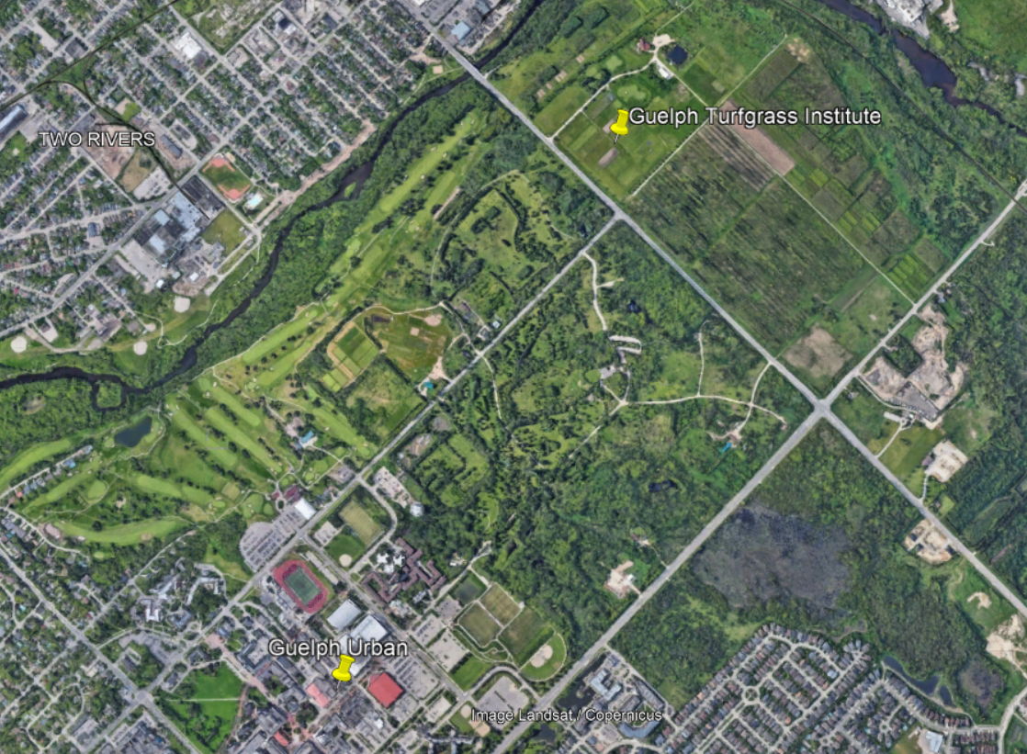

Figure 5 Map of weather station network during Guelph campaign in Ontario, Canada from July to September, 2018

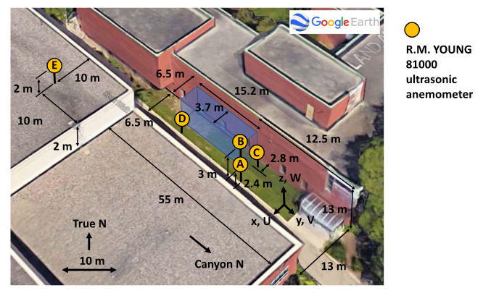

Figure View of locations for the urban measurements[10].

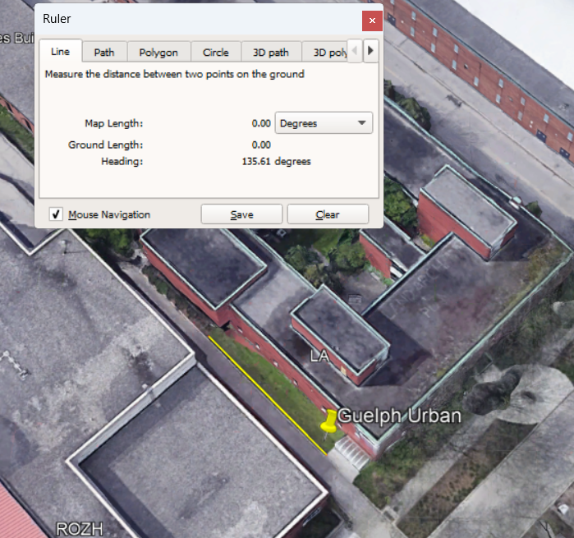

Figure 6 The canyon orientation is measured as -45 degree relative to north.

## Campaign introduction

The Guelph field measurements campaign has been conducted in Ontario, Canada, in 2018. The canyon height, canyon width and canyon orientation are measured from Google earth as 13m, 13m, and -45 degree relative to north. And the As summarized in [11], the neighborhood is classified as primarily commercial office area. In this study, Post 80s Medium Office 5A from DOE website [6] has been used as the prototype building energy model.

As for the rural weather observations dataset, the ERA5_Guelph_2015.epw has from [12] has been selected as the EPW template. The rural field measurements for the year 2018 are available via [13], in which the Guelph Turfgrass Institute (World Meteorological Organization, WMO ID 71833) datasets have been used as the actual measurements. Specifically, the dry bulb temperature, dew point temperature and relative humidity for the year 2018 have been used to compose the EPW file. The urban site measurements have 5 major anemometers, as illustrated in the above figure.

|  |  |  |
| --- | --- | --- |
|  |  | **Guelph** |
| **UWG** | **Theta of Canyon** | -45 |
| **[degree relative to north, -90 to 90]** |
| **Mean building heights[m]** | 13.25[10] |
| **Urban domain height [m]** | 40 |
| **Albedo (roof, wall, veg)** | - |
| **Emissitivities** | - |
| **(roof, wall)** |
| **Others** | Width canyon = 13m [Google earth]; Width roof = 13m❓ |
| **IDF** | **Prototype IDF models** | Post80s |
| MediumOffice 5A |
| **Internal Gains** | Office |
| **Cooling System** | Cooling |
| **Heating System** | Furnace |
| **Wall** | - |
| **Roof** | - |
| **Floor** | - |
| **Rural Weather Observations** | | Guelph Turfgrass Institute |
| (2 m air temperature relative humidity, dew point) |
| **Validating Weather Observations** | | Air temperature profile [2.4, 5.4, 17]m |

# References

[1] A. Christen and R. Vogt, “Energy and radiation balance of a central European city,” *International Journal of Climatology*, vol. 24, no. 11, pp. 1395–1421, 2004, doi: 10.1002/joc.1074.

[2] M. Moradi, E. S. Krayenhoff, and A. A. Aliabadi, “A comprehensive indoor–outdoor urban climate model with hydrology: The Vertical City Weather Generator (VCWG v2.0.0),” *Building and Environment*, vol. 207, p. 108406, Jan. 2022, doi: 10.1016/j.buildenv.2021.108406.

[3] B. Bueno, L. Norford, J. Hidalgo, and G. Pigeon, “The urban weather generator,” *Journal of Building Performance Simulation*, vol. 6, no. 4, pp. 269–281, Jul. 2013, doi: 10.1080/19401493.2012.718797.

[4] “BUBBLE - Basel Urban Boundary Layer Experiment.” https://www.mcr.unibas.ch/dolueg2/projects/campaigns/BUBBLE/textpages/ob_frameset.en.htm (accessed Oct. 21, 2022).

[5] V. Masson *et al.*, “The Canopy and Aerosol Particles Interactions in TOulouse Urban Layer (CAPITOUL) experiment,” *Meteorol Atmos Phys*, vol. 102, no. 3, p. 135, Dec. 2008, doi: 10.1007/s00703-008-0289-4.

[6] “Commercial Reference Buildings,” *Energy.gov*. https://www.energy.gov/eere/buildings/commercial-reference-buildings (accessed May 30, 2022).

[7] B. Crawford and A. Christen, “Spatial source attribution of measured urban eddy covariance CO2 fluxes,” *Theor Appl Climatol*, vol. 119, no. 3–4, pp. 733–755, Feb. 2015, doi: 10.1007/s00704-014-1124-0.

[8] “EnergyPlus.” https://energyplus.net/weather (accessed Oct. 21, 2022).

[9] “Data Search | National Centers for Environmental Information (NCEI).” https://www.ncei.noaa.gov/access/search/data-search/global-hourly (accessed Oct. 21, 2022).

[10] A. A. Aliabadi, M. Moradi, and R. A. E. Byerlay, “The budgets of turbulence kinetic energy and heat in the urban roughness sublayer,” *Environ Fluid Mech*, vol. 21, no. 4, pp. 843–884, Aug. 2021, doi: 10.1007/s10652-021-09800-x.

[11] M. Moradi *et al.*, “The Vertical City Weather Generator (VCWG v1.0.0),” *Copernicus Publications*, Aug. 2019, Accessed: Jun. 26, 2022. [Online]. Available: https://dspace.mit.edu/handle/1721.1/133020

[12] A. I. R. (AIR) Lab, “AmirAAliabadi/VCWGv1.3.2.” Aug. 03, 2022. Accessed: Oct. 24, 2022. [Online]. Available: https://github.com/AmirAAliabadi/VCWGv1.3.2

[13] E. and C. C. Canada, “Hourly Data Report for September 01, 2018 - Climate - Environment and Climate Change Canada,” Oct. 31, 2011. https://climate.weather.gc.ca/climate_data/hourly_data_e.html?hlyRange=2006-12-15%7C2022-04-12&dlyRange=2006-09-28%7C2022-04-12&mlyRange=2006-12-01%7C2006-12-01&StationID=45407&Prov=ON&urlExtension=_e.html&searchType=stnName&optLimit=yearRange&StartYear=1840&EndYear=2022&selRowPerPage=25&Line=3&searchMethod=contains&txtStationName=Guelph&timeframe=1&time=LST&time=LST&Year=2018&Month=9&Day=1# (accessed Oct. 24, 2022).

# Recycles

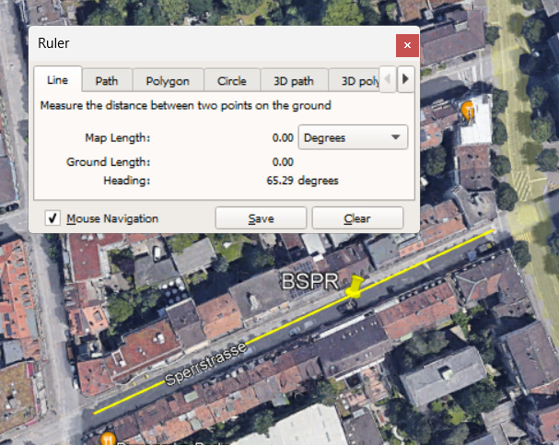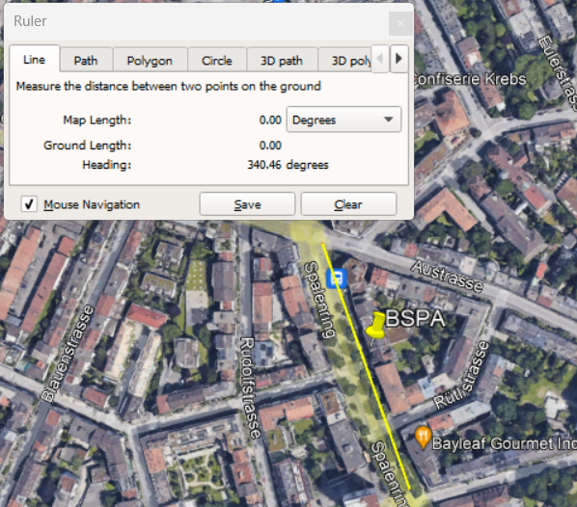

## Site configuration

Table 1 BUBBLE Urban Sites Surface Characteristics [1]

|  |  |  |
| --- | --- | --- |
|  | **Ue1 (BSPR)** | **Ue2 (BSPA)** |
| **Theta of canyon**  **[degree relative to north, -90 to 90]** | 65 | -20 |
| **Z_H: mean building height** | 14.6  nz_u = 14.6, nz = 50 | 12.5  nz_u = 12.5, nz = 40 |
| Lamda_p: plan aspect ratio | 0.54 | 0.37 |
| **Lamda_V: plan aspect ratio of vegetated surfaces** | 0.16  fveg_G = 0  fbare_G = 0.0  fimp_G = 1 | 0.31  fveg_G = 0.31  fbare_G = 0.0  fimp_G = 0.69 |
| Lambda_c: complete aspect ratio |  |  |
| **Lamda_s: mean street canyon height-to-width ratio** | 1  Width_canyon = 20.02 | 1  Width_canyon = 15 |
| Z_0 or Z_Ora: Roughness length |  |  |
| **Shortwave Albedo** | 15% | 11% |
| **Emissitivities** | 0.95 | 0.95 |
| **Cooling System** | No Cooling | No cooling |

1. City.

Basel Switzerland. The IECC climate zone and moisture regime: 4C (Seattle)

1. Canyon dimensions. See the above table.
2. Building constructions.

Including the above table, the building prototype IDF models has been selected as Post80s MidRiseApartment 4C.

1. Data collection.

|  |  |  |  |  |
| --- | --- | --- | --- | --- |
|  | **Urban/Rural** | **Elevation relative to sea level (m)** | **Latitude, Longitude** | **Variables** |
| Ue1 (BSPR) | Urban | 255 | 47°33'57.20"N,  7°35'48.80"E | Air temperature profiles  [2.6, 13.9, 17.5, 21.5, 25.5, 31.2] m |
| Ue2 (BSPA) | Urban | 278 | 47°33'17.60"N,  7°34'34.60"E | Air temperature profiles  [3, 15.8, 22.9, 27.8, 32.9] m |
| R1 (Grenzach) | Rural | 265 | 47°32'12.00"N,  7°40'31.50"E | Air temperature  1.5 m |

self.staInfra = numpy.array([cd[i][12] **for** i **in** range(len(cd))],dtype=float) *# horizontal Infrared Radiation Intensity [W m^-2]*self.staHor = numpy.array([cd[i][13] **for** i **in** range(len(cd))],dtype=float) *# horizontal radiation [W m^-2]*self.staDir = numpy.array([cd[i][14] **for** i **in** range(len(cd))],dtype=float) *# normal solar direct radiation [W m^-2]*self.staDif = numpy.array([cd[i][15] **for** i **in** range(len(cd))],dtype=float) *# horizontal solar diffuse radiation [W m^-2]*

1. date, format DD/MM/AAAA
2. time, format HHMNSS.SSS
3. air temperature (position 2 meters high) : *Celsius*
4. air pressure: hPa
5. relative humidity (position 2 meters high) : *%*
6. rain rate: mm/h
7. wind direction (position 10 meters high) : degree
8. wind speed (position 10 meters high) : m/s
9. incoming short wave radiation: *watts/m2*
10. outgoing short wave radiation: *watts/m2*
11. incoming long wave-Red radiation: *watts/m2*
12. outgoing long wave radiation: *watts/m2*
13. air temperature (position 6 meters high) : Celsius
14. air relative humidity (position 6 meters high) : Celsius